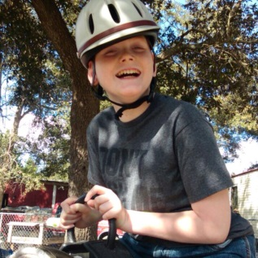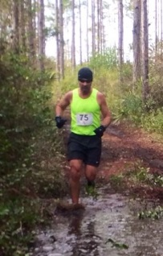

**Make checks payable to Hooves to Freedom.   
Mail the bottom of this form to Orrie McCrea @ 1601 Rainbow Dr., Waycross, GA 31501. For questions call (912)332-0837/**[**orriemccrea@gmail.com**](mailto:orriemccrea@gmail.com)

**Directions to Race: 1737 Tyre Bridge Road, Patterson, GA. From Waycross, head northeast on US-84 for approx. 17 miles. Turn left on to Tyre Bridge Road. Take 2nd right to stay on Tyre Bridge Rd. Race will be on the left, just past church. Look for signs.**

**----------------------------------------------------------------------------Cut Here------------------------------------------------------------------------------**

**5 mile runner** □ **$35**   **5 mile cross-country student** □ **$20**  ** 2 or more family members** □ **$30 each**

**T-shirt size**: **Youth** **S** □ **M** **□ L** □ **XL** □ **\*\*\*Separate forms required for each runner.**

**Adult** **size** **S** □ **M** **□ L** □ **XL** □ **2XL** □

**If we are out of shirts – 5 mile registration is $20.**

**Amount paid _______ Check #________ or Cash**

E-Mail _________________________________________________________ DOB__________ Phone #__________________

**Print** Name Race Day Age____ Sex (M)□ (F)□

Street____________________________________________City______________________State____ Zip __________

**Waiver:** In consideration of acceptance of this entry, I waive any and all claims for myself and my heirs against the officials, sponsors, and volunteers of the Okefenokee Track and Cycling Club, Hooves to Freedom, or Harley Davis for injuries or illnesses which may directly or indirectly result from my/my minor child’s participation in this event. I further state that I am/my minor child is in proper physical condition to participate in this event.

**Signature Date Parent or Guardian (if under 18)**

**The Superman Trail Race was inspired in the memory of “Superman” Brandon Davis, 1981-2013.**

**SUPERMAN 5 Mile TRAIL RACE**

Saturday, January 25, 2020

9:00 am registration opens

10:00 am 5 mile Race - $35 entry fee

(cross country students can register for $20)

*Jan. 19 is registration deadline to receive a shirt !!

*Hooves To Freedom* ─

#### **Proceeds will benefit** **Hooves to Freedom**, a non-profit organization, committed to the facilitation of healing through therapeutic horsemanship.

* **Location:** 1737 Tyre Bridge Rd., Patterson, GA 31557 - on the farm of Buck Davis.
* **Awards:** Overall, Masters (40+), Grand Masters (50+), & Top 3 Male and Female Runners in each age group.
* **Age Groups:** 12 and under, 13-19, 20-29, 30-39, 40-49, 50-59, 60-69, 70+
* **Fee** includes performance T-Shirt and sausage-dog lunch. Plus there will be a Live DJ!

RUNNER REGISTRATION FORM

